Please be sure to have completed the “Author Information Form” at the last page of the Template
PLEASE LEAVE THE HEADER AND FOOTER AREAS AS THEY ARE
A SWOT Analysis of Hospital Management
(Title in English; Centered, Bold, Title Case Heading ( bold with first letters of the words capital, Times New Roman 12 Font)
First Author & Second Author
Abstract
(https://apastyle.apa.org/instructional-aids/reading-abstracts.pdf )
Introduction: To introduce the topic and explain why the research is important.
Method: To describe how the authors conducted the research, with relevant details about
participants and variables examined.
Results or Findings: To describe what the authors found.
Discussion or Conclusion: To interpret the results, draw conclusions, describe implications for the real world and future research.
A summary not exceeding 250 words should be given. No other published work should be cited in the abstract which should include the objective Paragraph spacing in the abstracts should be written with single line spacing with zero (0) before and then eight pt (8 pt). space after the paragraph. It should be written in plain text form (not italic) and justified.
Keywords: hospital management, SWOT analysis, strength, weakness, opportunity, threat (There should be 3–6 keywords appropriate to the content of the article) lowercased (but capitalize proper nouns).
JEL Codes: M10,M21,C44, Z00 (There should be 3–6 JEL codes)

For those who do not know Turkish, Turkish title, abstract and keywords will be provided by the editors. If that is the case with you, please ignore this page.
LÜTFEN ÜST VE ALT BİLGİ KISIMLARINI OLDUĞU GİBİ BIRAKINIZ
Hastane Yönetim Süreci için SWOT Analizi
(Türkçe Başlık Ortalanmış, Birinci Düzey Başlık (kelimlerin sadece ilk harfleri büyük ve kalın Times New Roman 12 punto yazılmalıdır)
First Author & Second Author
Öz
(https://apastyle.apa.org/instructional-aids/reading-abstracts.pdf )
Giriş: Konuyu tanıtınız ve araştırmanın neden önemli olduğunu açıklayınız.
Yöntem: Araştırmayı nasıl yürüttüğünüzü katılımcılar ve incelenen değişkenler hakkında ilgili ayrıntılarla birlikte açıklayınız.
Sonuçlar ya da Bulgular: Çalışmanın sonuçlarını veya bulgularını anlatınız.
Tartışma ya da Yapılan Çıkarımlar: Sonuçları yorumlayarak çıkarımlarda bulununuz; gerçek dünya ve gelecekteki araştırmalar öneriler getiriniz.
250 kelimeyi geçmeyen bir özet verilmelidir. Özet kısmında başka bir yayınlanmış çalışmaya atıf yapılmamalıdır. Özetlerde paragraf aralığı önce sıfır (0) sonra sekiz nk(8nk) satır aralığı tek ve iki yanayaslı yazılmalıdır. Düz yazı formunda (italik değil) yazılmalıdır.
Anahtar Kelimeler: hastane yönetimi, SWOT analizi, güçlü yön, zayıf yön, fırsat, tehdit (Özetlerin altında makalenin içeriğine uygun 3–6 adet anahtar kelime yer almalıdır). küçük harfle (ancak özel isimleri büyük harfle yazın).
JEL Kodlar: M10,M21,C44, Z00

(Özetlerin altında makalenin içeriğine uygun 3–6 adet JEL kodları yer almalıdır).Muscript should be at least 4000 words and at most 30 pages long, excluding abstracts and bibliography. Manuscripts must be written in Microsoft Office Word 2007 or later.
The journal template and page layout are designed in portrait orientation. Therefore, changing the page orientation to landscape in Microsoft Word is not permitted.
Tables and figures must be arranged in a way that conforms to the portrait layout without disrupting the page structure. Large tables and figures are expected to be reformatted accordingly.
Any formatting that disrupts the consistency of the journal template will not be accepted.
Headings in Main Body of the Text
(First Level Headings: Centered, Bold, First Letters Capitalized)
The paragraph below the first-level heading must start one tab from the left.

(Second Level Headings: Left Aligned, Bold, First Letters Capitalized)
The paragraph below the second level heading must start one tab from the left.

(Third Level Headings: Left Aligned, Bold, Italic,First Letters Capitalized)
The paragraph below the third-level heading must start one tab from the left.

(Fourth Level Headings: First Line One tab from the left, Bold, First Letters Capitalized, Ending with a Period. The text starts on the same line and continues as a normal paragraph.

(Fifth Level Headings: First Line One tab from the left, Bold, Italic, First Letters Capitalized, Ending with a Period. The text starts on the same line and continues as a regular paragraph.

Heading levels should follow each other hierarchically. For example, after the first-level heading, do not use a third-level heading without using a second-level heading.
For information on APA STYLE Version 7 title levels, see the relevant page: https://apastyle.apa.org/style-grammar-guidelines/paper-format/headings

Introduction (First Level Heading)
(First Level Heading should be written in bold and centered with only the first letters capitalized. Times New Roman Font 12 points, bold). Only the first letters of the words should be capitalized, the other letters should be lowercase.
The paragraph under the Introduction must start one tab from the left side.
Text main body: Times New Roman, 12 font, single spacing, justified.
Paragraph Order: Paragraphs should start one tab in from the left, no extra space should be left before the paragraf and 8pt of space should be left after the paragraph.
The manuscript should be written in A4 size paper, The page margins should be set to 2.5 cm from each side (top, bottom, right, left 2.5 cm). The format of this file is adjusted accordingly. Please do not change it.
Literature Review (First Level Heading)
It is not obligatory to follow the subject headings given here, and it is recommended that the authors make the changes they consider to be appropriate.
Method (First Level Heading)
Methodus in praxi electa fundata est in principio, quod medii et inferiores administratores ac negotiatores operarii in hospitali monitore laborantes mutationes fiendas in consumables medicorum intra ambitum qualitatis cycli, eas si non est problema, considera. si queritur et caveas.
“ Since a(n) ……… was used in this study as a data collection method, the permission has been obtained from Ethics Committee of the ………… University with a decision on the date of DD.MM.YYYY and document number………...”
Select the method you used in your research from the list below and fill in the first two blanks with it:
Any kind of research: conducted with qualitative or quantitative approaches that requires data collection from participants using survey, interview, focus group interview, observation, experiment, conversation.

Data Set Second Level Headings should be Left Aligned, Bold and First Letters Capitalized.
Finis huius recensionis erit tam qualitatem quam parabilem materias, quae in foro inveniri possunt, determinare voluntas tua. The first paragraph after the second level heading should start one tab from the left.
Demographics (Third Level Headings Should Be Left Aligned, Bold, Italicized and First Letters Capitalized)
Omnes participes qui rogationum impleverunt in nosocomio tempore applicationis functionis laborabant. Interrogationes collectae et responsa ad singulas quaestiones singulatim perpensa sunt. The first paragraph after the third level heading should start one tab from the left.
Gender. Ex ordine proventuum Mann-Whitney U experimenti in hac tabula, ostenditur mares nutrices altiorem perceptionem instrumentorum electronicarum quam feminae nutrices habere. Alia inventio ex hac tabula colligitur quod participes, qui satisfaciunt de operibus suis, majorem habent perceptionem amoris patientis, quam illi qui displicent. (Fourth Level Headings First Line One tab from the left, Bold, First Letter Capitalized and Ended with a Period.) The first paragraph after the fourth level heading should start on the same line and continue as a normal paragraph.
Cum hoc, propter probationis independentis specimen applicatum satisfactionis officium variae et condiciones corporis variabiles (t=-3.553, sig.= .001), observatum est peraeque significantem relationem inter condiciones physicas esse. et satisfactio officium, cum 5% gradu significat. Cum corporis conditionum emendatione, exempli gratia, ad solvendas quaestiones in numero personarum, vias sternens ad onus laboris minuendum et ad illum finem ampliora officia praebendo, campestris satisfactionis.augeri potest.
Change of Response Difference by Gender. Ex analysi inter variabiles institutionis personarum et corporis condiciones, relatio significativa et positiva inter has duas variabiles deprehensa est. Negatio et significativa relatio observata est inter apparatum electronicum perceptio praefectorum participum et aegri ordinationes et informationes patientis. . (Fifth Level Headings First Line One tab from the left, Bold, Italic, First Letters Capitalized and Ended with a Period. The first paragraph after the fifth level heading should start on the same line and continue as a normal paragraph.
Expertus statisticus et ordines consecuti sunt ex testo Mann-Whitney U, inter varia armorum electronicorum et variabilium genera et variabilis amoris patientis et variabilis satisfactionis operae provisa sunt.

Paragraph editing image is given below.
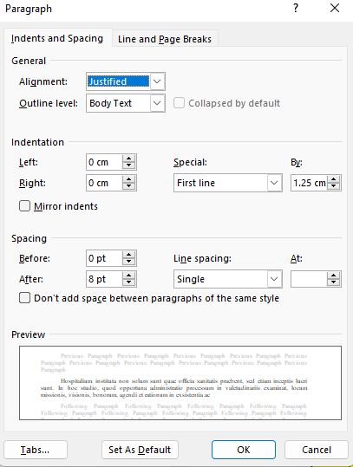

Explanations on Citations in the Main Text Body:

Citing an article in the text
In the APA 7 reference system, authors can make two separate styles of references, both acceptable, in their articles.
A parenthetical citation should be given as (Devanny & Gearson, 2021) in parenthesis. The “&” sign should be used in place of the word “and”.For example:
A fragmented domestic agenda won't produce the strength and cohesion of thought needed to play an active role in the world (Devanny & Gearson, 2021).
In the Narrative citation method, the surname(s) of the directly cited author(s) appears in the text.Year of publication is added in parentheses after the author's name and the sentence continues. It should be given as Devanny and Gearson (2021) in the in-text narration; the word “and” should be used instead of the “&” sign. For example:

As Devanny and Gearson (2021) argue, the UK will not be able to realise its 'Global Britain' ambitions unless it first addresses domestic issues as well as those linked to its current and potential relations with Europe.

Citing a book in the text
If there are two authors:
It should be given as (Devanny & Gearson, 2021) in parenthesis. The “&” sign should be used in place of the word “and”.For example:
A fragmented domestic agenda won't produce the strength and cohesion of thought needed to play an active role in the world (Devanny & Gearson, 2021).
It should be given as Devanny and Gearson (2021) in the in-text narration; The word “and” should be used instead of the “&” sign. For example:
As Devanny and Gearson (2021) argue, the UK will not be able to realise its 'Global Britain' ambitions unless it first addresses domestic issues as well as those linked to its current and potential relations with Europe.

If there are three or more authors

It should be given as (Hanley et al., 2019) in Parenthetical citation

It should be given as Hanley et al. (2008) in Narrative citation
Display of an article in the References
In case of article citation, the first letter of the first word in the article title should be capitalized, the remaining letters of the word and other words should be written in lower case. Afterwards, the journal name should start with a capital letter and be written in italics. Journal volume number should be italicized but the issue number should be plain in parenthesis. Page range should be given, followed by a dot. The article doi number, if any, should be given lastly.
Valentine, S. & Fleischman, G. (2008). Ethics programs, perceived corporate social responsibility and job satisfaction. Journal of Business Ethics, 77(2), 159-172. https://doi.org/10.1007/s10551-006-9306-z

Representation of a book in the References
The title of the book should be italicized and the first letter of the first word in the title should be capitalized, the remaining letters of the word and other words should be in lowercase. The title of the book should have a dot at the beginning and end, and then the name of the publisher should be given with a plain and capital letter.
Hanley, N., Shogren, J., & White, B. (2019). Introduction to environmental economics. Oxford University Press. (Only the publisher should be given, but not the place of publication).
7th edition published by the American Psychological Association (APA) should be followed.
For more information about APASTYLE 7 th on cases not mentioned above, you can refer to the following page:
https://apastyle.apa.org/style-grammar-guidelines/references/examples/

Use of Footnotes
Footnotes that can only be used to provide explanatory information. They should be written in 10 font and single line spacing.

Quotations:
Direct quotations of less than 40 words should be shown in quotation marks and in accordance with the format used throughout the article. For example:
Shared values, fundamental to British national identity, on the other hand, consist of a “commitment to universal human rights, the rule of law, free speech and fairness and equality” (Cabinet Office, 2021, p. 13).
Direct quotations which include more than 40 words should be shown as a block, without quotation marks, indented 1.25 cm from the left.
Parenthetical citation example:
Security concerns and trade relations have been central in the UK- China bilateral relations for decades and so will be the next decade. Integrated Review points out that:
China’s growing international stature is by far the most significant geopolitical factor in the world today, with major implications for British values and interests and for the structure and shape of the international order. The fact that China is an authoritarian state, with different values to ours, presents challenges for the UK and our allies. China will contribute more to global growth than any other country in the next decade with benefits to the global economy. China and the UK both benefit from bilateral trade and investment, but China also presents the biggest state-based threat to the UK’s economic security. (Cabinet Office, 2021, p. 62)
Narrative citation example:
Introduction of artificial intelligence into finance seems to have changed some traditional approaches. Juan Coffi and Babu George (2022) states:
Robo-advisors definitely have the potential to positively disrupt the financial advising and investment market. Wealth management firms have learned to incorporate these tools in a collaborative rather than competitive way. While some have externalized them, many companies have even learned how to build them in-house. (p.266)

For information about APA STYLE version 7 Quotations, please refer to the relevant page. https://apastyle.apa.org/style-grammar-guidelines/citations/quotations

Explanation about Tables and Figures to be included in the full text
The main body of tables and figures should be written in Times New Roman, 10 fonts (not italic). Tables annd figures should be placed in the text aligned to the left.
If Tables or figures are not suitable for inclusion in the text, they should be placed at the end of the text and immediately after the References, in “Appendix”.
The display should follow the following order.
“Table”/ “Figure” followed by sequence number
Heading of the Table/Figure
Table/Figure image
Note.
Please check the sample images below.

Figure 1 (justified left, Times New Roman 12 font, plain text, bold)
Economic Growth and Changes in Poverty Rates (2009–2020) (justified left, Times New Roman 12 font, italic)
Attention: All text that appears within figure images—including labels, axis titles, annotations, and other text elements—must be in Arial font, 10-point size.

Note. This figure was created by the authors using Microsoft Excel. The data were obtained from the World Bank and TurkStat (Online), Labour Force Statistics and Income and Living Conditions Statistics, 2025. Economic growth data were obtained from the World Bank.

Figure 2 (justified left, Times New Roman 12 font, plain text, bold)
Comparison of Companies’ Net Sales Revenue and Capital Expenditures. (justified left, Times New Roman 12 font, italic)
Attention: All text that appears within figure images—including labels, axis titles, annotations, and other text elements—must be in Arial font, 10-point size.

Note. This figure was created by the author using Microsoft Excel. The data were extracted from the companies' annual reports covering the period 2020–2022.

Figure 3 (justified left, Times New Roman 12 font, plain text, bold)
Conceptual Model of the Study (justified left, Times New Roman 12 font, italic)
Attention: All text that appears within figure images—including labels, axis titles, annotations, and other text elements—must be in Arial font, 10-point size.

Customer Engagement (CEn)
H₁ H₂
Brand Image (BIm)
Brand Loyalty (BLo)
Brand Attachment (BAtt)
H₃ H₄

Note. This figure was created by the author via IBM SPSS AMOS 24.
Attention: If the computer program you used to prepare the figure does not allow you to create the figure in Arial font with a 10-point size and transfer it into your manuscript, you may insert the figure as a screenshot. In this case, please refer to the examples below for the statements that should be included below the figure.
Figure 4 (justified left, Times New Roman 12 font, plain text, bold)
Annual Scientific Production (justified left, Times New Roman 12 font, italic)
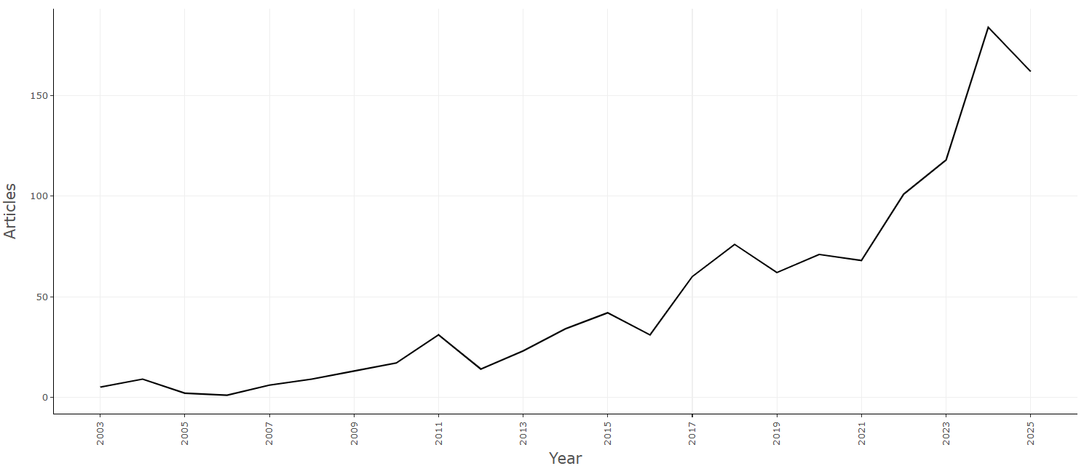
Note. This figure was created via Biblioshiny, where Arial font customization is not supported.

Figure 5 (justified left, Times New Roman 12 font, plain text, bold)
Word Cloud (justified left, Times New Roman 12 font, italic)
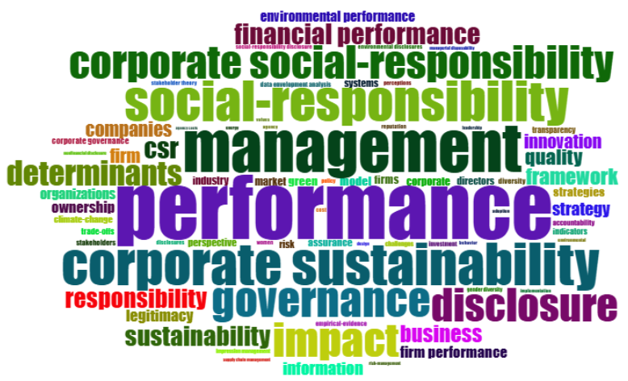
Note. Word cloud of search results. This figure was created via Biblioshiny, where Arial font customization is not supported.
Explanations, including the sources, should be given below the figure/table as a “Note”. It should be written in Times New Roman, 12 font. A single dot should be placed after the word “Note”.

You can refer to the links below for various sample figures.
https://apastyle.apa.org/style-grammar-guidelines/tables-figures/sample-figures
https://apastyle.apa.org/style-grammar-guidelines/tables-figures/colors

Table 1 (justified left, Times New Roman 12 font, plain text, bold)
Basic Statistical Indicators (justified left, Times New Roman 12 font, italic)
Unlike the figures, please use the use font Times New Toman with a type size 10 points.

Statistic | CCE | FDI | GRW | TRD
Mean | -0.448 | 5.114 | 3.840 | 83.664
Median | -0.464 | 3.517 | 4.079 | 81.020
Maximum | 0.828 | 55.073 | 34.466 | 166.147
Minimum | -1.264 | -5.678 | -28.759 | 40.834
Std. Dev. | 0.459 | 6.444 | 5.845 | 25.329
Skew. | 0.428 | 4.552 | -0.161 | 0.516
Kurt. | 2.755 | 31.308 | 10.519 | 2.795
J-B | 8.719 | 9726.920 | 623.023 | 12.174
Prob. | 0.013 | 0.000 | 0.000 | 0.002
Total | -118.334 | 1350.029 | 1013.879 | 22087.220
Num. of Obs. | 264 | 264 | 264 | 264
Note. The dataset was derived from the official World Bank WGI and WDI and calculated by the author using EViews 12 for Windows statistical software
Table 2
Likelihood of Participation in the EU Constitution Referendum in France
 | Definitely No | Probably No | Maybe | Probably Yes | Definitely Yes | Total
Number of Respondents | 167 | 28 | 47 | 58 | 670 | 970
Percentage | 17,22% | 2,89% | 4,84% | 5,98% | 69,07% | 100%
Note. Created by the author using the Eurobarometer 63.4 (May-June 2005) data set in IBM SPSS Statistics 28.

Table 3
The Digital Privacy Concern by Educational Level
Chi-Square Tests
 | X² | V | df | p | n
Pearson Chi-Square | 44,634 |  | 21 | ,002 | 300
Cramer's V |  | ,223 |  | ,002
Note. Created by the author using IBM SPSS Statistics 27 statistical software.

Table 4
ADF and Fourier ADF Unit Root Test Results
Variable | Form | Frequency | Fourier ADF | F-stat. | ADF | Decision
LNTPP | Level | 1 | -1.399 | 19.697* | -2.576 | I(1)
LNTPP | First difference | 4 | 0.410 | 2.321 | -6.705*
LNTRADE | Level | 4 | -0.164 | 4.758 | -3.065 | I(1)
LNTRADE | First difference | 4 | -4.493 | 5.126 | -5.043*
LNFDI | Level | 1 | -3.630 | 4.314 | -1.264 | I(1)
LNFDI | First difference | 5 | -6.470 | 1.015 | -6.391*
LNHC | Level | 1 | -3.420 | 8.919*** | -0.608 | I(1)
LNHC | First difference | 4 | -4.555 | 0.400 | -6.110*
LNRD | Level | 4 | 0.016 | 2.304 | -0.486 | I(1)
LNRD | First difference | 4 | -4.517 | 2.505 | -7.244*
Note. Created by the author using data obtained from the Penn World Table, World Bank, TurkStat, the Council of Higher Education, and EViews statistical software. The symbols *, **, and *** refer to significance at the 1%, 5%, and 10% levels, respectively.

You can refer to the link below for various sample tables.
https://apastyle.apa.org/style-grammar-guidelines/tables-figures/sample-tables
Explanations, including the sources, should be given below the figure/table as a “Note”. It should be written in Times New Roman, 12 font. A single dot should be placed after the word “Note”.
Tables should be placed left-justified in the text and numbered sequentially (Table 1, Table 2 etc.).
Figures should be placed left-justified in the text and numbered sequentially (Figure 1, Figure 2 etc.).
If there are sources of tables or figures, they should be given in “Note”, according to the in-text citation rules. Times New Roman should be written in 12 font size (not italic).
For more sample Table and Figure displays;
See: https://apastyle.apa.org/style-grammar-guidelines/tables-figures

Authors must add a page break by using the "Insert>Page Break" menu before every case they want to have at the beginning of the page (for example, before tables that should not be divided).

Explanation About Mathematical and Statistical Symbols and Equations
If the text contains mathematical and statistical symbols, they should be prepared using the Microsoft Office Equation Editor (Insert>Equation).
If there are equations, they should be numbered starting from 1. Equation sequence numbers should be placed in parenthesis to the right of the equation line. An extra space should be left above and below the equation in question.
The membership function of the triangular fuzzy number is defined in Eq. (1).

 | $$μ(x|(\tilde{M})\left\{\begin{aligned}\begin{matrix}0 & x<1, \\ (x-l)/(m-l) & l≤x≤m,\end{matrix} \\ \begin{matrix}(u-x)/(u-m) & m≤x≤u, \\ 1 & x>u.\end{matrix}\end{aligned}\right.$$ | (1)

Hypotheses, if used, should be written as follows.
H1: Habitus insignem effectum habet in intentione ad mores.
H2: Percepta morum imperium signanter afficit intentionem morum.
H3: Normae personales significanter se gerendi intentionem afficiunt.
H4: Est relatio inter humanitatis imperium et normas personales percipi.

Building on these theoretical insights and empirical findings, the present study formulates the following hypotheses regarding the relationship between inflation and the functional composition of public expenditures:
H1: The functional composition of public expenditures has a significant relationship with inflation dynamics.
H2: Different categories of public expenditures exhibit heterogeneous causal relationships with inflation.
H3: Structural shifts in fiscal policy regimes influence the causal interaction between public expenditures and inflation.

Numbered Lists
When creating a numbered list, use the “numbered list” feature of your word-processing program. This will automatically indent the list. Use Arabic numerals followed by a period; do not enclose the number in parentheses or follow it with parentheses.
Example of a numbered list:
With higher load factors and labour cost benefits, a 60% decline in expenses has resulted in the establishment of new markets, and the flow of traffic has increased by 3-4 times the former levels on several routes. LCC airlines have grown and incrementally exceeded the network carrier markets. For instance, Southwest Airlines began operating transcontinental flights in the US as an enduring network carrier hub, serving as a base for development. Network Carriers have come back in two ways;
- The foundation of low-cost and in-airline strategies.
- Venture to lift an important amount of costs from their operations, but without changing their business passenger models.
https://apastyle.apa.org/style-grammar-guidelines/lists/numbered

Bulleted Lists
To create a bulleted list, use the “bulleted list” feature of your word-processing program. This feature will automatically indent the list. Symbols such as small circles, squares, dashes, and similar marks may be used as bullets.
If the items in a bulleted list are complete sentences, begin each one with a capital letter and end it with appropriate punctuation (usually a period). The example below demonstrates this format and shows how to include a citation for information presented in a bulleted list.
Example of a bulleted lists
The findings reveal three major discussion points regarding what the language of policy documents and speeches say, and what power relations are masked by these discourses:
- Indifference to the open higher education reality despite the large portion it bears in the Turkish higher education system
- Negligence of the contributions of the system to inclusion in higher education and thus to social justice and democracy
- No permanent and valuable place for distance education in regular universities in the new normal, only for emergency cases.
https://apastyle.apa.org/style-grammar-guidelines/lists/bulleted
If the items in a bulleted list are not complete sentences, present them as shown in the example below.
Another one example of a bulleted lists
Accounting-based (traditional) financial performance measurement methods are as follows;
- return on assets (ROA)
- return on equity (ROE)
- earnings per share (EPS)
- price/earnings (P/E Ratio)
- net present value (NPV)
- internal rate of return (IRR)

Conclusion
(First Level Headings: Centered, Bold, First Letters Capitalized, Times New Roman 12 font). It is very important to have this section in your article. Please be sure to follow the format as explained.
In the conclusion section, the authors are expected to interpret and discuss the research findings in a detailed, consistent, and logical manner. More clearly stated;
- Explaining the meaning of the results: The findings should not merely be presented; their meaning, why they are important, and how they relate to previous research should be clearly articulated.
- Developing strong and persuasive arguments: The author should present a convincing discussion by using evidence and reasoning that support the validity and reliability of the findings.
- Providing appropriate context: The results should be evaluated within the framework of the research question, the existing literature, and potential limitations; for example, in articles involving statistical/econometric analysis, merely presenting numerical results is not sufficient.
- Comparison and critical analysis: The findings should be compared with previous studies, similarities and differences should be discussed, and possible explanations should be provided.
Creating Bookmarks and Hyperlinks Between In-Text Citations and the Reference List (Word 365)
The following guide demonstrates, step by step, how to create bookmarks and hyperlinks between in-text citations and the reference list in Microsoft Word 365. Authors are required to apply this procedure in their manuscripts. Upon completion of this process, the relevant in-text citations in the manuscript will be hyperlinked to their corresponding reference list entries, individual equation numbers, individual tables, and individual figures.
The Bookmark and Hyperlink connections between in-text citations, reference list entries, tables, figures, and equation numbers should be added after the peer-review process of the manuscript has been completed and the final version has been prepared. Performing these operations during the revision process is not recommended. Authors should create the relevant connections in the final version of the accepted manuscript before publication.

Sample text
Unit Root Test
CD, which is occasionally observed in panel data sets, poses significant challenges to the validity of econometric analyses. A review of the relevant literature on this issue indicates that, for first-generation unit root tests (Levin et al., 2002; Im et al., 2003) to yield valid results, it is necessary to assume the absence of any CD (Chang et al., 2023; Husein, 2024; Anavatan & İspir, 2025). However, if a CD is present in the series, the literature widely accepts that the reliability of first-generation tests is compromised. Those methodological limitations demand the use of second-generation unit root tests that account for cross-sectional dependence (Baltagi, 2005; Breitung & Pesaran, 2008). In this context, this study uses the CIPS (Cross-sectionally Augmented IPS) unit root test developed by Pesaran (2007), which models CD through common factors.
The CIPS test controls for cross-sectional correlation by including common factors in the panel via principal components and cross-sectional averages, thereby increasing the validity of unit root tests. The CIPS test is calculated using the following formula. Eq. (1):

$CIPS= \overline{t}=\frac{1}{N}\sum_{i}^{N}{t_{i}(N,T)}$ (1)

The results obtained from the applied CIPS unit root test are presented in Table 1.
Table 1
CIPS Unit Root Test Results
Variable | CIPS Statistic | Variable | CIPS Statistic | Critical Values
 |  |  |  | 1% | 5% | 10%
CCE | -2.029 | ΔCCE | -4.062* | -2.96 | -2.76 | -2.66
FDI | -2.616 | ΔFDI | -4.982* | -2.96 | -2.76 | -2.66
TRD | -2.097 | ΔTRD | -4.152* | -2.96 | -2.76 | -2.66
GRW | -1.822 | ΔGRW | -4.759* | -2.96 | -2.76 | -2.66
Note. The dataset was derived from the official World Bank WGI and WDI and calculated by the author using EViews 12 for Windows statistical software
The test was estimated under the constant + trend specification. The null hypothesis $H_{0}$indicates that the series are not stationary (contain a unit root). Significance stars (*, **, ***) indicate significance levels of 1%, 5%, and 10%, respectively. Critical values for the constant + trend model were determined as -2.96 for 1%, -2.76 for 5%, and -2.66 for 10%, based on N=12, T=21−22. Figure 1, derived from the CIPS unit root test results, reflects that none of the variables are stationary at levels, whereas all become stationary after first differencing.
Figure 1
CIPS Unit Root Test Results

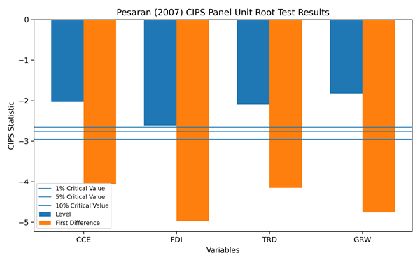
Note. This figure was created via Python, where Arial font customization is not supported.

References
Anavatan, A., & İspir, M. S. (2025). Stochastic convergence behaviour in carbon dioxide emissions: Fourier panel unit root approach, Applied Economics, 57(60), 11228-11241. https://doi.org/10.1080/00036846.2025.2450385
Baltagi, B. H. (2005). Econometric analysis of panel data (3rd ed.). John Wiley & Sons.
Breitung, J., & Pesaran, M. H. (2008). Unit roots and cointegration in panels. In L. Mátyás & P. Sevestre (Eds.), The econometrics of panel data: Fundamentals and recent developments in theory and practice. (pp. 279-322). Springer. https://doi.org/10.1007/978-3-540-75892-1_9
Chang, T., Wang, M. C., Jia, L., & Ranjbar, O. (2023). Degree of persistence of energy mix diversification of the US states: Fresh evidence using LM unit root tests with sharp or smooth breaks and cross-sectional dependence. Environmental Science and Pollution Research, 30(39), 91415-91439. https://doi.org/10.1007/s11356-023-28662-y
Husein, J. (2024). Tourism in ASEAN‐5: A novel panel unit‐root test for shocks persistence with gradual structural breaks and common factors. International Journal of Tourism Research, 26(1), Article 2602. https://doi.org/10.1002/jtr.2602
Im, K. S., Pesaran, M. H., & Shin, Y. (2003). Testing for unit roots in heterogeneous panels. Journal of Econometrics, 115(1), 53-74. https://doi.org/10.1016/S0304-4076(03)00092-7
Levin, A., Lin, C. F., & Chu, C. S. J. (2002). Unit root tests in panel data: Asymptotic and finite-sample properties. Journal of Econometrics, 108(1), 1-24. https://doi.org/10.1016/S0304-4076(01)00098-7
Pesaran, M. H. (2007). A simple panel unit root test in the presence of cross-section dependence. Journal of Applied Econometrics, 22(2), 265-312. https://doi.org/10.1002/jae.951

Creating Bookmarks and Adding Hyperlinks in a Word 365 Document
Recommended Workflow
✅ Complete the manuscript.
✅ Finalize the reference list.
✅ Finalize the table and figure numbering.
✅ Finalize the equation numbering.
✅ Add bookmarks to all target items.
✅ Add hyperlinks to the in-text citations.
✅ Perform a final review.
1. Adding a Bookmark
This process is used to mark a specific entry so that it can be accessed quickly from within the document.
- Go to the References section and locate the Levin (2002) entry.
- Place the cursor at the beginning of the Levin (2002) reference (either at the start of the line or the beginning of the text).
- Click the Insert tab on the ribbon.
- In the Links group, select Bookmark.
- In the dialog box that opens, assign a bookmark name (e.g., Levinetal2002).
- Do not use spaces (for example, "Levin et al., 2002" is not a valid bookmark name).

Guidelines for Naming Bookmarks
When creating a bookmark, follow these naming rules:
- Do not use spaces.
- Do not use commas (,).
- Do not use periods (.).
- Do not use quotation marks (" or ').
- Do not use parentheses ( ).
- Do not use forward slashes (/) or backslashes (\).
- Do not use special characters such as !, ?, &, %, +, or =.
- Use only letters and numbers.
✔ Correct example: Levinetal2002
❌ Incorrect examples: Levin et al., 2002 / Levinetal 2002 / (Levin et al-2002)
- Click the Add button.

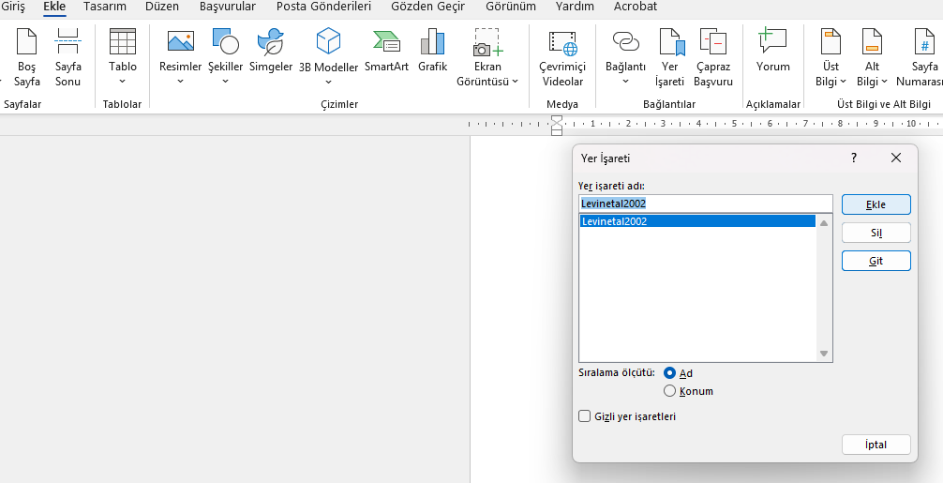
After this step, the selected reference list entry is saved as a bookmark.
2. Adding a Hyperlink to an In-Text Citation
This step is performed to link the in-text citation (Levin et al., 2002) to its corresponding entry in the reference list.
- Select the in-text citation (Levin et al., 2002) using the mouse.
- Right-click the selected text and choose Link. Click Insert Link.
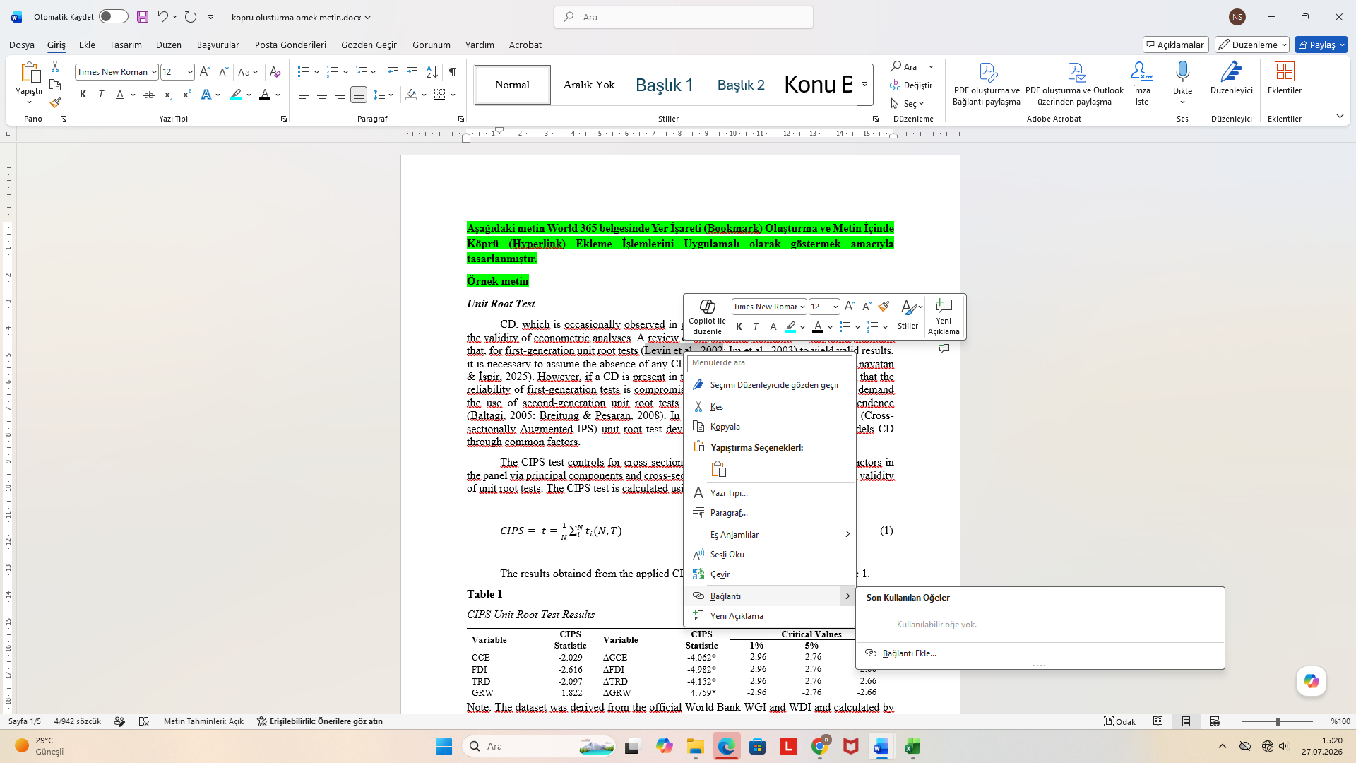

- In the Insert Hyperlink window, click the Place in This Document option on the left side.
- Locate the Bookmarks section in the list.
- Select the Levinetal2002 bookmark that you created previously.
- Click the OK button.
- After the selection is made, the text will turn blue. Leave it in blue and do not change the color.
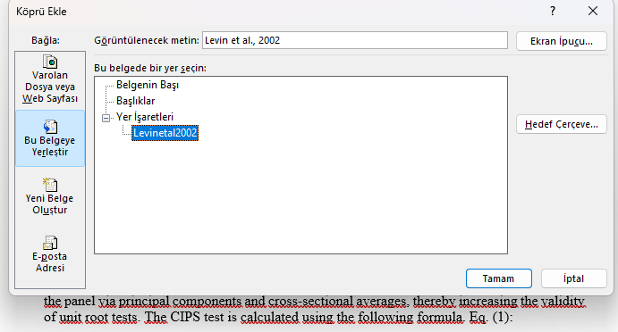
………………………………………………………………………………………………
3. Activating the Hyperlink
- The in-text citation (Levin et al., 2002) has now become an underlined hyperlink.
- To follow this link:
  - Hold down the Ctrl key and click.
- Word will take you directly to the (Levin et al., 2002) entry in the reference list.
……………………………………………………
Adding Bookmarks to Equations
Go to the beginning of the equation number and locate the (1) entry, for example.
Place the cursor at the beginning of the (1) entry. The remaining steps are the same as described above.
…………………………………………………………
Adding Bookmarks to Tables
Go to the beginning of the word Table and locate the Table 1 entry, for example.
Place the cursor at the beginning of the Table 1 entry. The remaining steps are the same as described above.
……………………………………………
Adding Bookmarks to Figures
Go to the beginning of the word Figure and locate the Figure 1 entry, for example.
Place the cursor at the beginning of the Figure 1 entry. The remaining steps are the same as described above.
Note: “The interface and menu steps may vary slightly in different versions of Microsoft Word.”

References (First Level Heading)
At the end of the text, there should be a “References” section which will be arranged alphabetically according to the surnames of the authors.
Attention: The References Section should not start from where the text of the study ends, it should go to the next page. A page break before References (using “Insert>Page Break” menu option).should be used.
References text (Times New Roman Font, 12 font, Normal). Special hanging 1.25 should be chosen. References line spacing should be 8 pt.
Its image is given below.
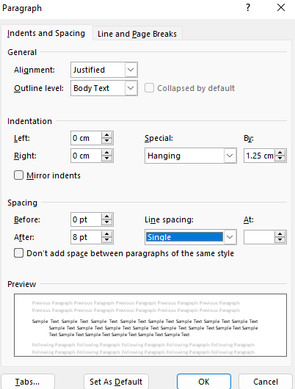

7th edition published by the American Psychological Association (APA) should be followed.
There is no need to group the references as books, articles, other internet resources etc.

The references should include only the publications used in the manuscript.

Referencing Style
- Ensure that all sources cited in the text are included in the reference list, and that all sources in the reference list are cited in the text. This is important for effective and accurate indexing and for establishing appropriate scientific citation networks between publications.
- At least 80% of the sources in the reference list must have a DOI index(number). The DOI index must be provided for all sources that have one. When providing the DOI index, use the formatting style shown in the following example.
Valentine, S. & Fleischman, G. (2008). Ethics programs, perceived corporate social Responsibility and job satisfaction. Journal of Business Ethics, 77(2), 159-172. https://doi.org/10.1007/s10551-006-9306-z (Example of article with DOI number)
- The sources should have been published within the last 5 years (more than 70%) and should be primarily selected from peer-reviewed journals published by high-quality publishers. The use of sources other than journal articles should be minimized (less than 20%)
- References should not include unpublished source materials (unpublished master's and doctoral theses are exempt from this rule).
- Citations of non-academic and non-peer-reviewed sources, such as blog posts, Wikipedia, anonymous sources, and non-scientific or commercial websites, should be avoided or minimized.

Article
Ahmad, A. & Thyagaraj, K. S. (2015), Consumer’s intention to purchase green brands: The roles of environmental concern, environmental knowledge and self-expressive benefits, Current World Environment, 10(3), 879-889. (Article example)
Carbado, D., Crenshaw, K.W., Mays, V. M., & Tomlinson, B. (2013). Intersectionality: Mapping the movements of a theory1. Du Bois review: Social Science Research on Race, 10(2), 303-312. (Article example)
Çelik, T. (2023). Türkiye’de kayıt dışı istihdam sorunu kalıtsal mıdır?. [CEEİK 2023 Özel Sayısı]. Bandırma Onyedi Eylül Üniversitesi Sosyal Bilimler Araştırmaları Dergisi, 6, 93-110. https://doi.org/10.38120/banusad.1384690 ( special issue article)
Valentine, S. & Fleischman, G. (2008). Ethics programs, perceived corporate social Responsibility and job satisfaction. Journal of Business Ethics, 77(2), 159-172. https://doi.org/10.1007/s10551-006-9306-z (Example of article with DOI number)
(Article With Volume Number Only) (Missing Issue Number)
Zhang, B., Wang, B., & Wang, Z. (2017). Role of renewable energy and non-renewable energy consumption on EKC: Evidence from Pakistan. Journal of cleaner production, 156, 855-864. https://doi.org/10.1016/j.jclepro.2017.03.203
(Article With Issue Number Only) (Missing Volume Number)
Durdu, M. (2018). Maliye politikalarının belirlenmesinde sivil toplum kuruluşlarının rolü. Selçuk Üniversitesi Sosyal Bilimler Enstitüsü Dergisi, 39, 15–28.
(If the Journal Article has an Article Number Instead of a Page Range)
Chen, L., Zhuo, Y., Xu, Z., Xu, X., & Gao, X (2019). Is carbon dioxide (${CO}_{2}$) emission an important factor affecting health care expenditure? evidence from China, 2005-2016. International Journal of Environmental Research and Public Health, 16(20), Article 3995. https://doi.org/10.3390/ijerph16203995

Online Magazine Article
McCauley, D.,& Brashares ,J. ( 2025, April 27). Forget dire wolves. Here’s what we really need in the fight against extinction. Time. https://time.com/7280557/what-we-really-need-in-the-fight-against-extinction/

Online Newspaper Article
Kaplan, Sarah. (2025, April 16). Is the planet losing one of its best ways to slow climate change?. The Washington Post. https://www.washingtonpost.com/climate-environment/2025/04/16/what-record-spike-planet-warming-gases-says-about-health-earth/
Newspaper Article Without An Author Name
Halkevlerinin yıldönümü dün memleketin her tarafında tes’it edildi. (1933, Şubat 25). Cumhuriyet Gazetesi.
Gazi Hz. dün İstanbul’lularla temas etti. (1930, Aralık 20). Hâkimiyet-i Milliye.

Webpage on a News Website
Hughes, R. A.(2025, April 23).How Europe’s great spa towns are shoring themselves up against the threat of climate change. Euronews. https://www.euronews.com/travel/2025/04/23/how-europes-great-spa-towns-are-shoring-themselves-up-against-the-threat-of-climate-change

Book
Hanley, N., Shogren, J., & White, B. (2019). Introduction to environmental economics. Oxford University Press. (Book example)
Metin, B. (2013). Türkiye’de 2000 sonrası dönemde uygulanan ekonomik ve sosyal politikalar temelinde yoksulluk sorunu, Ankara’da uygulamalı bir araştırma. T.C. Çalışma ve Sosyal Güvenlik Bakanlığı Çalışma ve Sosyal Güvenlik Eğitim ve Araştırma Merkezi Yayınları. (Book example)
(Book, Republished in Translation)
Althusser, L. (1991). İdeoloji ve devletin ideolojik aygıtları. (Y. Alp., & M. Özışık. Çev.). İletişim Yayınları. (Book, republished in translation)
Badinter, E. (2011). Kadınlık mı? Annelik mi? (A. Ekmekci, Çev.). İletişim Yayınları. (Book, republished in translation)
Skousen, M. (2022). The making of modern economics: The lives and ideas of great thinkers. (4th ed.). Routledge. (Reprint of the same book)
Şenses, F. (2019). Küreselleşmenin öteki yüzü: Yoksulluk (9. baskı). İletişim Yayınları. (Reprint of the Turkish same book)
Beauvoir, S. (1993). Kadın “ikinci cins” genç kızlık çağı. (B. Onaran, Çev.). Payel Yayınları. (Book, republished in translation)
Kandiyoti, D. (2019). Cariye, bacılar, yurttaşlar: Kimlikler ve toplumsal dönüşümler (A. Bora, F. Sayılan, Ş. Tekeli, H. Tapınç, & F. Özbay, Çev.; 6th ed.). Metis Yayınları. (Republished in translation and reprint of the same book)
Schumpeter, J. A. (1939). Business cycles: A theoretical, historical and statistical analysis of the capitalist process. Vol. 1. McGraw-Hill Book Company. (Book with only volume number)
Özgen, Y. (Ed.). (2024). Atatürk’ün söylev ve demeçleri. Cilt III. (1925-1938). Atatürk Araştırma Merkezi, Türk İnkılâp Tarihi Enstitüsü. (A book edited by an editor, gathering various works together)
Marx, K. (1972). Capital: A critique of political economy. (Vol. 1; S. Moore., & E. Aveling. Trans.). International Publishers. (Original work published 1867) (Displaying volume number in a translated work)
Marx, K. (2020). Theories of surplus value, (Volume 3; S. Ryazanskaya, Trans.; D. Y. Riazanov, Ed.). Progress Publishers. (Original work published 1863) (Book with volume number, translation, and edited by)
Marx, K., & Engels, F. (1848). The Communist Manifesto. (S. Moore, Trans.). Penguin Books. (Original work published 1848) Retrieved June 1, 2025, from https://www.hetwebsite.net/het/profiles/manifest.htm (Translation book accessed online)
Chapter in an Edited Book
Clower, R. W. (2004). Trashing J.B. Say: The story of a mare’s nest. In K. V. Velupillai (Ed.), Macroeconomic theory and economic policy (pp. 101-110). Routledge. (Chapter in an edited book)
Aronoff, D. (2016). The Malthus-Ricardo debate on general glut and secular stagnation. In A Theory of accumulation and secular stagnation: A Malthusian approach to understanding a contemporary malaise (pp. 10-43), Palgrave Pivot. https://doi.org/10.1057/9781137562210_2 (Chapter in an edited book, example of book with DOI number)
Kadıoğlu, A. (2008). Milliyetçilik-liberalizm ekseninde vatandaşlık ve bireysellik. İçinde T. Bora & M. Gültekingil (Eds.), Modern Türkiye’de siyasi düşünce: Milliyetçilik (Cilt 4, ss. 284–292). İletişim Yayınları. (Displaying volume number in an edited book)
Reprint of the Orginal Book
Malthus, T. R. (1989). Principles of political economy. Cambridge University Press. (Original work published 1820)
Malthus, T. R. (2018). An essay on the principle of population: The 1803 edition. Yale University Press. (Original work published 1803)
Ricardo, D. (2001). The principles of political economy and taxation, Batoche Books. (Original work published 1817)
A Book With an Organızatıon as the Author
Türkiye İstatistik Kurumu. (2020). Türkiye’nin istatistik yıllığı 2020 (Yayın No. 4620).Türkiye İstatistik Kurumu Yayınları.
Compilation Book
Unan, N. (Derleyen). (1952). Atatürk’ün söylev ve demeçleri. Cilt II. Türk İnkılap Tarihi Enstitüsü Yayınları.
Özgen, Y. (Ed.). (2024). Atatürk’ün söylev ve demeçleri. Cilt III. (1925-1938). Atatürk Araştırma Merkezi, Türk İnkılâp Tarihi Enstitüsü.
Conference/ Symposium/ Congress
Pede, V. O., Sparks, A. H., & McKinley, J. D. (2012, February). Regional income inequality and economic growth: A spatial econometrics analysis for provinces in the Philippines. Paper presented at the 56th Annual Conference of the Australian Agricultural and Resource Economics Society, Fremantle, Australia. Australian Agricultural and Resource Economics Society. Retrieved September 18, 2025, from https://www.aares.org.au/conference
Chapter in a Conference/Symposium/Congress Proceedings Book
Siham, A., Sekkate, S., & Adib, A. (2021). Feature selection based on machine learning for credit scoring: An evaluation of filter and embedded methods. In Z. H. Kilimci, T. Yildirim, V. Piuri, I. Czarnowski, D. Camacho, Y. Manolopoulos, & S. Solak (Eds.), Proceedings of the 2021 International Conference on INnovations in Intelligent SysTems and Applications (INISTA 2021) (pp. 1–6). IEEE. https://doi.org/10.1109/INISTA52262.2021.9548410
Pay attention to the difference between the two examples. According to APA 7, a conference paper is not treated like a “chapter in a book”; it is considered an independent presentation or event. In the second example, there is no proceedings book. Italics are used only for the title of the book or report; chapter titles and conference names are written in plain text. The publisher/organizing body is also written in plain text.
Sun, J., & Li, W. Q. (2011, October 22–25). The non-government organizations' cultivation and promotion of soft power. In H. Zhang & K. Zhu (Eds.), Soft power innovation anddevelopment in today's China: Proceedings of the First International Conference of National Soft Power (pp. 61–62). Aussino Academic Publishing House.
Yavuzaslan, K., & Cetin, M. (2016). Soft power concept and soft power indexes. In M. H.Bilgin, H. Danis, E. Demir, & U. Can (Eds.), Business challenges in the changing economic landscape: Vol. 1. Proceedings of the 14th Eurasia Business and Economics Society Conference (pp. 395–409). Springer Cham. https://doi.org/10.1007/978-3-319-22596-8_28

Kumar, P., & Schoenebeck, S. (2015, February). The modern day baby book: Enacting goodmothering and stewarding privacy on Facebook. In D.Cosley, A.Forte, L.Ciolfi &D.McDonald (Ed.), Proceedings of the 18th ACM conference on computer supportedcooperative work & social computing (pp. 1302-1312). ACM Press.

Toprak, Z. (1977). Halkçılık ideolojisinin oluşumu. İçinde A. Aksay & M. Pirili (Eds.). Atatürk döneminin ekonomik ve toplumsal sorunları sempozyumu kitabı, (ss.13-31). Yüksek İktisat ve Ticaret Mektebi, Mezunları Derneği Yayını
Chapter in a Proceedings Book Published by an Organization with No Editor Specified

Umar, M. (2021, April 18-19). Re-examining the impact of remittances on human development: Evidence from Sub-Saharan Africa. In Scientia Moralitas Conference Proceedings (pp.51-60). Scientia Moralitas Research Institute. http://scientiamoralitas.education/wpcontent/uploads/2021/05/01237.pdf

Publication in an Abstract Book

Taiwo, A. (2025, September 26-28). Negotiating patriarchy in Nigerian society: Representations of female identity in Nollywood films. In Abstract book of the World Conference on Gender and Women’s Studies (Vol. 3, No. 1, p. 24). Proud Pen.

Handbook
Haughton, J., & Khandker S. R. (2009). Handbook on poverty and inequality. World Bank.

Theses
Alabaş, A. (2007). Uzun süreli işsizler ve uzun süreli işsizliği azaltmada işkur’un önemi [Yayımlanmamış uzmanlık tezi]. T.C. Çalışma ve Sosyal Güvenlik Bakanlığı, Türkiye İş Kurumu Genel Müdürlüğü.
Dansuk, E. (1997). Türkiye’de yoksulluğun ölçülmesi ve sosyo-ekonomik yapılarla ilişkisi [Yayımlanmış uzmanlık tezi]. Devlet Planlama Teşkilatı.
İncedal, S. (2013). Türkiye’de yoksulluğun boyutları: Mücadele politikaları ve müdahale araçları [Yayımlanmamış aile ve sosyal politikalar uzmanlık tezi]. Aile ve Sosyal Politikalar Bakanlığı Sosyal Yardımlar Genel Müdürlüğü.
Şahin, T. (2009). Sosyal dışlanma ve yoksulluk ilişkisi. [Yayımlanmış sosyal yardım uzmanlık tezi]. T.C. Başbakanlık Sosyal Yardımlaşma ve Dayanışma Genel Müdürlüğü.
Evcim, N. (2023). Türkiye ve dünyada çalışan yoksulluğu. [Yayımlanmamış doktora tezi]. Pamukkale Üniversitesi.
Şeker, S. D. (2011). The dynamics of poverty in Turkey. [Unpublished doctoral dissertation]. Middle East Technical University.
Güldal, B. (2024). Türkiye'de yoksulluğun analizi: 2006–2023 dönemi sürekli yoksulluğun belirleyicileri. [Yayımlanmamış yüksek lisans tezi]. İstanbul Üniversitesi.
Ulga, E. (2022). Türkiye'de ekonomik büyümenin yapısı ve istihdam etkileri. [Yayınlanmamış yüksek lisans tezi]. Bursa Uludağ Üniversitesi.

Discussion Paper
Islam, R. (2004, January). The nexus of economic growth, employment and poverty reduction: An empirical analysis. (Issues in employment and poverty Discussion Paper, No. 14). Recovery and Reconstruction Department International Labour Office. https://www.ilo.org/media/315761/download ( The month and year of internet publication are known)
Working Paper
Akpan, U.F., & Chuku, A. (2011, April 27). Economic growth and environmental degredation in Nigeria. Beyond the environmental kuznet curve. MPRA Paper No.31241, https://mpra.ub.uni-muenchen.de/31241/ (Example of working paper) (internet publication date is known)
Fernández-Villaverde, J. (2001, December 16). Was Malthus right? Economic growth and population dynamics (PIER Working Paper No.01-046). Penn Institute for Economic Research. http://dx.doi.org/10.2139/ssrn.293800 (Example of working paper with DOI number) (internet publication date is known)
Hulme, D., Moore, K., & Shepherd, A. (2001, November 1). Chronic poverty: Meanings and analytical frameworks. Chronic Poverty Research Centre Working Paper. https://doi.org/10.2139/ssrn.1754546 (Example of working paper with DOI number) (internet publication date is known)
Arndt, C., Mahrt K., & Schimanski, C. (2017, June). On the poverty–growth elasticity. WIDER Working Paper Series. https://doi.org/10.35188/unu-wider/2017/375-2 (Example of working paper with DOI number) ( The month and year of internet publication are known)
Azevedo, J. P., & Atamanov, A. (2014, April). Pathways to the middle class in turkey: How have reducing poverty and boosting shared prosperity helped?. Policy Research Working Paper Series. http://hdl.handle.net/10986/17722 (Example of working paper with DOI number) ( The month and year of internet publication are known)
Khan, A. R. (2007, July). Growth, employment and poverty: An analysis of the vital nexus based on some recent UNDP and ILO/ SIDA studies. DESA Working Paper. https://www.un.org/esa/desa/papers/2007/wp49_2007.pdf (Example of working paper) ( The month and year of internet publication are known)
Eyck, K.V. (2003). Flexibilizing employment: An overview. SEED Working Paper, Retrieved June 15,2024, from https://www.ilo.org/media/313116/download (Example of working paper with DOI number) (Since the month and year of publication are unknown, the internet access date is given)

Outlook and Overview

ILO (2024, November 28). World employment and social outlook: Trends 2025 in figures. https://www.ilo.org/resource/other/world-employment-and-social-outlook-trends-2025-figures (Example of outlook) (internet publication date is known)
World Bank Group (n.d.). Poverty overview. Retrieved March 4, 2025, from https://www.worldbank.org/en/topic/poverty/overview Example of overview) Since the month and year of publication are unknown, the internet access date is given)

Workshop (Çalıştay)
Koç Üniversitesi TÜSİAD Ekonomik Araştırma Forumu. (2008, Aralık 20). Tüketim harcamaları, gelir dağılımı ve yoksulluk istatistikleri çalıştayı, EAF & TÜİK ortak çalıştayı, TÜİK Yoksulluk Çalışmaları. https://eaf.ku.edu.tr/events/tuketim-harcamalari-gelir-dagilimi-ve-yoksulluk-istatistikleri-calistayi-eaf-tuik-ortak-calistayi20-aralik-2008/ (internet publication date is known)

Development Plans
T.C. Devlet Planlama Teşkilatı. (2007). Dokuzuncu kalkınma planı: Gelir dağılımı ve yoksullukla mücadele özel ihtisas komisyonu raporu. Ocak 15, 2024 de https://www.sbb.gov.tr/wp-content/uploads/2022/08/Dokuzuncu-Kalkinma-Plani-Gelir-Dagilimi-ve-Yoksullukla-Mucadele-OIK.pdf den erişildi (Example of development plan) (Since the month and year of publication are unknown, the internet access date is given)
T.C. Kalkınma Bakanlığı. (2018). On birinci kalkınma planı (2019-2023) İşgücü piyasası ve genç istihdamı. Nisan 01, 2024 de https://www.sbb.gov.tr/wp-content/uploads/2020/04/IsgucuPiyasasi_ve_GencIstihdamiOzelIhtisasKomisyonuRaporu.pdf den erişildi (Example of development plan) (Since the month and year of publication are unknown, the internet access date is given)

Report
T.C. Aile ve Sosyal Hizmetler Bakanlığı. (t.y.). Sosyal içerme alanında ASPB'nin kurumsal kapasitesinin geliştirilmesi projesi (1.3. Faaliyeti RAPOR 2: Gelir, istihdam, eğitim, mesleki eğitim ve yoksulluk ilişkilerinin incelenmesi yoksulluğun ve sosyal dışlanma süreçlerinin araştırılması, politikaların incelenmesi). Ocak 15, 2024 de https://aile.gov.tr/media/100418/rapor2.pdf den erişildi (Example of report) (Since the month and year of publication are unknown, the internet access date is given)
İklim Haber, (t.y.) IPCC 1,5°C Raporu. Haziran 25, 2024 de https://www.birbucukderece.com/bilimsel-kaynaklar/ipcc-1-5-c-raporu den erişildi(Example of report) (Since the month and year of publication are unknown, the internet access date is given)
Türkiye Cumhuriyet Merkez Bankası, (2023, Ocak 26). Enflasyon Raporu. https://www.tcmb.gov.tr/wps/wcm/connect/16bb648b-19b7-4da1-bbda-dc75d5dedbb9/enfocak23_i_tam.pdf?MOD=AJPERES&CACHEID=ROOTWORKSPACE-16bb648b-19b7-4da1-bbda-dc75d5dedbb9-onJblzA (internet publication date is known)
World Bank. (2004). World Development Report. The International Bank for Reconstruction and Development/ The World Bank (Physically printed publication)
United Nations Development Programme (UNDP), Türkiye. (2025, May 30). White paper – policy recommendations for NEET young women in Türkiye [White paper]. https://www.undp.org/turkiye/publications/white-paper-policy-recommendations-neet-young-women-turkiye (white paper)
Edited Report With a DOI
Pörtner, H.O., Roberts, D.C., Tignor, M., Poloczanska, E.S., Mintenbeck, K., Alegría, A., Craig, M., Langsdorf, S., Löschke, S., Möller, V., Okem, A.& Rama B. (eds.). (2022). Climate change 2022: Impacts, adaptation and vulnerability. Contribution of working group II to the sixth assessment report of the ıntergovernmental panel on climate change, Cambridge University Press. https://doi.org/10.1017/9781009325844
Lee, H & Romero J. (eds.). (2023). Summary for policymakers. In: Climate change 2023: synthesis report. contribution of working groups I, II and III to the sixth assessment report of the intergovernmental panel on climate change, IPCC, https://doi.org/10.59327/IPCC/AR6-9789291691647.001
Edited Report Without a DOI Number
Field, C.B., Barros, V.R., Dokken, D.J., Mach, K.J., Mastrandrea, M.D., Bilir, T.E., Chatterjee, M., Ebi, K.L., Estrada, Y.O., Genova, R.C., Girma, B., Kissel, E.S., Levy, A.N., MacCracken, S., Mastrandrea, P.R., & White L.L. (eds.) (2014). Impacts, adaptation, and vulnerability. Part A: Global and sectoral aspects. Contribution of working group II to the fifth assessment report of the ıntergovernmental panel on climate change. Cambridge University Press.
Religious Work
English Standard Version Bible. (2001). ESV Online. https://esv.literalword.com/

Encyclopedia
Haveman, R.H. (2001). Poverty: Measurement and analysis. International Encyclopedia of the Social & Behavioral Sciences (pp. 11917-11924). Pergamon.
Dictionary
Bannock, G., Baxter, R. E., & Davis E. (1987) Classical economics. In The Penguin dictionary of economics (4th ed., pp. 70-72), Penguin Books.
Lecture Notes
Uğur, A. (2021, Ekim 03). Dünyada ve Türkiye'de Bankacılığın Tarihi, Banka ve Finansal Kurumlar Ders Notu 2. https://avesis.inonu.edu.tr/ahmet.ugur/dokumanlar (internet publication date is known)

Briefing
The Economist Briefing (2022, October 06) Ukraine’s military success is reshaping Russia as well as the war, The Economist. https://www.economist.com/briefing/2022/10/06/ukraines-military-success-is-reshaping-russia-as-well-as-the-war (internet publication date is known)
Press Release
US Department of State .(2023, June 2). Russia’s Strategic Failure and Ukraine’s Secure Future [Press release]. https://www.state.gov/russias-strategic-failure-and-ukraines-secure-future/ (internet publication date is known)
Blog
Suárez, G. (2015, Eylül 10). Motherland: The traditional community and the modern individual come face to face. Cineuropa. https://cineuropa.org/en/newsdetail/298367/ (internet publication date is known)
Myers, K. (2018, October 17). The top 9 causes of global poverty. InterAction. https://www.interaction.org/blog/the-top-9-causes-of-global-poverty/ (internet publication date is known)

Karl ,N.& Habtom,T.(2024, September 05). Western Seizure of Russian Central Bank Assets Risks Sparking Global Pushback. Transnational Litigation Blog. https://tlblog.org/western-seizure-of-russian-central-bank-assets-risks-sparking-global-pushback/ (internet publication date is known)

Portal
World Bank Group (n.d.). Climate Change Knowledge Portal. Retrieved December 17, 2024, from https://climateknowledgeportal.worldbank.org (Internet publication date is unknown)
Statistical Institution Data
Türkiye İstatistik Kurumu. (2024a, Ekim 10). Gelir dağılımı istatistikleri. https://data.tuik.gov.tr/Bulten/Index?p=Gelir-Dagilimi-Istatistikleri-2023-53840 (internet publication date is known)
Türkiye İstatistik Kurumu. (2024b, Ağustos 12). İşgücü istatistikleri. https://data.tuik.gov.tr/Bulten/Index?p=Isgucu-Istatistikleri-Haziran-2024-53512 (internet publication date is known)
Türkiye İstatistik Kurumu. (2024c, Aralık 27). Gelir ve yaşam koşulları araştırması metaverisi. https://data.tuik.gov.tr/Bulten/Index?p=Gelir-Dagilimi-Istatistikleri-2024-53712(internet publication date is known)
Türkiye İstatistik Kurumu. (2024d, Temmuz10). Hanehalkı işgücü istatistikleri metaverisi. https://data.tuik.gov.tr/Bulten/Index?p=Isgucu-Istatistikleri-Mayis-2024-53522(internet publication date is known)
Türkiye İstatistik Kurumu. (t.y). Uluslararası seçilmiş göstergeler. Ocak 16, 2025 de https://biruni.tuik.gov.tr/secilmisgostergeler/ den erişildi (Since the month and year of publication are unknown, the internet access date is given)
Türkiye İstatistik Kurumu. (t.y.). Gelir ve yaşam istatistikleri, MEDAS (Merkezi Dağıtım Sistemi). Ocak 16, 2025 de https://biruni.tuik.gov.tr/medas/?locale=tr den erişildi (Since the month and year of publication are unknown, the internet access date is given)
Türkiye İstatistik Kurumu. (t.y.). Gelir ve yaşam koşulları araştırması metodolojisi hakkında genel açıklama. Nisan 1, 2024 de https://data.tuik.gov.tr/Bulten/DownloadFile?p=VeDNHyETiaKvhA12s81sMdLQ7sshD2clioqVgfwAZT5HG5UoGE0MVg/gWKTMAfFib384JebOEhuqXTnXdvZZb/1putPuHKtwHI5C5r55GJM= den erişildi (Since the month and year of publication are unknown, the internet access date is given)
Turkish Statistical Institute. (2022). Household labor force survey 2022 [Data set].https://www.tuik.gov.tr/Kurumsal/Mikro_Veri

Official Gazette
Resmi Gazete. (1928, Haziran 4). 904 sayılı Türk Vatandaşlık Kanunu.
Resmi Gazete. (1928, Kasım 24). 1048 sayılı Millet Mektebi Talimatnamesi.
The Minutes of the Grand National Assembly of Türkiye
Türkiye Büyük Millet Meclisi Zabıt Ceridesi. (1336, Mayıs 1). Devre 1, Cilt 1, İçtima 1.
Türkiye Büyük Millet Meclisi Zabıt Ceridesi. (1337, Kasım 26). Devre 1, Cilt 14, İçtima 2.
Türkiye Büyük Millet Meclisi Zabıt Ceridesi. (1923, Mart 1). Devre 1, Cilt 28, İçtima 1.

Law
Türkiye Büyük Millet Meclisi. (1924). Teşkilât-ı Esasiye Kanunu (Kanun No. 491). Haziran 30, 2025 de https://www.anayasa.gov.tr/tr/mevzuat/onceki-anayasalar/1924-anayasasi/ den erişildi(Since the month and year of internet publication are unknown, the internet access date is given)
International Criminal Court. (1998). Rome Statute of the International Criminal Court. Retrieved May 22, 2025, from https://www.icc-cpi.int/resource-library/Documents/RS-Eng.pdf (Since the month and year of internet publication are unknown, the internet access date is given)

Court Decision
International Criminal Tribunal for Rwanda. (2003). Judgment: Prosecutor v. Ferdinand Nahimana, Jean-Bosco Barayagwiza and Hassan Ngeze (ICTR-99-52-T). Retrieved May 22, 2025, from https://www.refworld.org/jurisprudence/caselaw/ictr/2003/en/91852(Since the month and year of internet publication are unknown, the internet access date is given)

Other Internet Resource Examples
U.S. Census Bureau. (n.d.). Turkey. U.S. Department of Commerce. Retrieved May 5, 2023, from https://www.census.gov/popclock/world/tu (internet resource example) (Since the month and year of internet publication are unknown, the internet access date is given)
ILO (n.d.). Decent work. Retrieved Jan 17, 2024, from https://www.ilo.org/topics/decent-work (internet resource example) (Since the month and year of internet publication are unknown, the internet access date is given)
Ziady H. (2023, May 4) European Central Bank hikes rates by a quarter-percentage point. CNN. https://edition.cnn.com/2023/05/04/economy/european-central-bank-interest-rates/index.html (internet resource example) (internet publication date is known)
Using Two Surnames in the Reference List
According to APA 7, when an author has two surnames, the reference list entry should reproduce the name exactly as it appears in the work. The full surname is treated as a single last name, followed by the initials of the author’s given name(s).
Surname (if two-part, complete), Initial(s) of given name.
Özmen Bol, Z., & Cantürk, S. (2025). Changes in health expenditure relative to inflation: Prospective implications for Türkiye. International Journal of Economics and Administrative Studies, (49), 37-50. https://doi.org/10.18092/ulikidince.1608149
You can refer to the link below for various Reference examples.
https://apastyle.apa.org/style-grammar-guidelines/references/examples/
Appendix
Appendix 1: (For example a colon should be placed after the word Appendix 1).

Author Information Form
Each author's information should be filled out separately in both English and Turkish.
Her yazar için yazar bilgileri hem İngilizce hem Türkçe olarak ayrı ayrı doldurulmalıdır.

1st Author Information
Title, ........ Üniversity, Faculty of ........, , Department of ........, City,Country/Region ...........@.........., ORCID ID: https://orcid.org/0000-...............

Unvan, …………….Üniversitesi, ............. Fakültesi, .................. Bölümü, Şehir/Ülke, ................@ ..............., ORCID ID: https://orcid.org/0000....................
The author's phone number. (__) _______________
OR (If not affiliated to a university) EĞER (Bir Üniversite ile bağlantılı değilse)
Title, ........ Affiliation, ........,………… City,Country/Region ...........@.........., ORCID ID: https://orcid.org/0000-...............

Unvan, ……………. Bağlantı, ............. Şehir/Ülke, ................@ ..............., ORCID ID: https://orcid.org/0000....................
The author's phone number. (__) _______________
2nd Author Information
Title, ........ Üniversity, Faculty of ........, , Department of ........, City,Country/Region ...........@.........., ORCID ID: https://orcid.org/0000-...............

Unvan, …………….Üniversitesi, ............. Fakültesi, .................. Bölümü, Şehir/Ülke, ................@ ..............., ORCID ID: https://orcid.org/0000....................
The author's phone number. (__) _______________

OR (If not affiliated to a university) EĞER (Bir Üniversite ile bağlantılı değilse)
Title, ........ Affiliation, ........,………… City,Country/Region ...........@.........., ORCID ID: https://orcid.org/0000-...............

Unvan, ……………. Bağlantı, ............. Şehir/Ülke, ................@ ..............., ORCID ID: https://orcid.org/0000....................
The author's phone number. (__) _______________
(IMPORTANT : Please remember to indicate which of the following titles you hold: Prof. Dr. / Assoc. Prof./ Asst.Prof.Dr. /Ph.D. Candidate/ Research Assistant Dr./Lecturer/Master’s Degree Student/ / Independent Researcher Dr. (Doesn't work for a university but has completed his/her PhD)/ MSc, MA, Independent Researcher (If none of the above).
If the number of authors is more than two, please indicate the information of the other author(s) in the same way.
Indicate who is the corresponding author………………………………………………
Article Type: JATSS classifies articles according to their content: research article, case report, review, etc. Please specify the type of your article). ………………………………………………
Were the ethical rules for research and publication followed while preparing the article?......................
Was any External financing used ? If yes, please indicate financial source: ………………… ……………………………………………………………………………….
The corresponding author should contact all contributing authors to determine whether there is a conflict of interest/ /competing of interest and answer the following questions behalf of all the authors:
Are there any conflicts of interest /competing of interest to be declared by the author(s) ? ..............
If the answer is yes, please explain the nature of the conflict of interest /competing of interest.
……………………………………………………………………………………
……………………………………………………………………………………
The above explanation should include the name(s) of the author(s) with the declared conflict of interest /competing of interest. These names will be kept confidential. If the article is published, the relevant conflict of interest /competing of interest information will be indicated with a statement in the published article text.
Did you generate this article from a thesis? …………………………………
If yes, please provide the thesis citation according to the examples below
Example 1 This study is derived from the master's thesis/ Ph.D. dissertation titled "……………………" completed by the first author under the supervision of the second author at the Department of ………………., Institute of Social Sciences, ………………. University.
Örnek 1 Bu çalışma …………… Üniversitesi Sosyal Bilimler Enstitüsü ……….. Anabilim Dalı’nda birinci yazar tarafından ikinci yazarın danışmanlığında tamamlanmış olan “………………………………” başlıklı yüksek lisans/doktora tezinden türetilmiştir.
If your situation aligns with Example 1, refer to the following article to understand how to present this information in your manuscript: https://doi.org/10.37241/jatss.2025.120
Example 2 This study is derived from the Ph.D. dissertation “……………………………..” completed by the author under the supervision of the Prof. Dr./ Assoc. Prof.…………………… at the Department of ……………………., Institute of Social Sciences, …………… University.
Örnek 2 Bu çalışma …………… Üniversitesi, Sosyal Bilimler Enstitüsü, …………… Anabilim Dalı’nda yazar tarafından Prof. Dr./Doç.Dr. ………………… danışmanlığında tamamlanmış olan “……………………………………..” başlıklı doktora tezinden türetilmiştir.
If your situation corresponds to Example 2, refer to the following article to understand how to present this information in your manuscript: https://doi.org/10.37241/jatss.2025.131
Declaration of the Use of Artificial Intelligence/Generative Artificial Intelligence
Before completing the section below, please read the information provided in the JATSS Artificial Intelligence (AI) and Generative Artificial Intelligence (GenAI) Use and Disclosure Policy tab.
Did you benefit in any way from generative artificial intelligence programs during the preparation, execution, data analysis, or any other stages of this article? ……………………………………………
If your answer is yes, please explain at which stage(s) you used generative artificial intelligence programs: The AI declaration may be as follows:
During the preparation of this manuscript, [name of AI/GenAI tool] was used for [purpose of use]. The tool was used during [stage/section]. All outputs provided by the AI tool were reviewed and verified by the author(s). The author(s) remain fully responsible for the scientific content, accuracy, originality, and integrity of the work.
Örnek 1: During the preparation of this manuscript, ChatGPT (OpenAI) was used to improve the grammar, spelling, clarity, and readability of text created by the authors. The tool was used during the writing stage for language editing purposes. All outputs provided by the AI tool were reviewed and verified by the authors. The authors remain fully responsible for the scientific content, accuracy, originality, and integrity of the work.
Örnek 2: Generative AI tools, specifically ChatGPT and GitHub Copilot, were used to assist with language editing and portions of the code development. All outputs were reviewed and validated by the authors.
With this declaration, the author(s) accept(s) that, if at any time a situation contrary to the above statement is identified, all ethical, academic, and legal responsibility shall rest with them.
Files to be uploaded to the system must be named with the surnames of the authors. (Example: surname.doc).

Author Info. Title, ........ Üniversity, Faculty of ........, Department of ........, City/Country, ...........@.........., ORCID ID: https://orcid.org/0000-............... (Corresponding Author)
Author Info. Title, ........ Üniversity, Faculty of ........, Department of ........, City/Country, ...........@.........., ORCID ID: https://orcid.org/0000-...............
Yazar Bilgileri Unvan, …………….Üniversitesi, ............. Fakültesi, .................. Bölümü, Şehir/Ülke, ................@ ..............., ORCID ID: https://orcid.org/0000.................... (Sorumlu Yazar)
Yazar Bilgileri Unvan, …………….Üniversitesi, ............. Fakültesi, .................. Bölümü, Şehir/Ülke, ................@ ..............., ORCID ID: https://orcid.org/0000....................
Permission was obtained from the Ethics Committee of …………………… University with the decision dated DD.MM.YYYY and document number ……….

